**Lesson13 Azure blob Versioning**

**Notes:-**

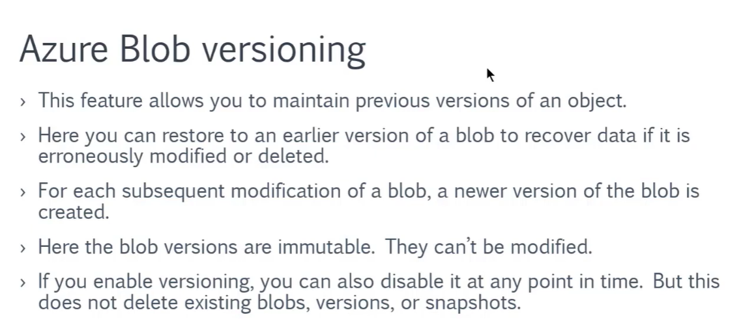

**(With azure blob versioning you have ability to restore your deleted blobs at any time)**

**Steps:-**

**1-on azure 🡪 storage account 🡪 make sure you enable version level immutability**

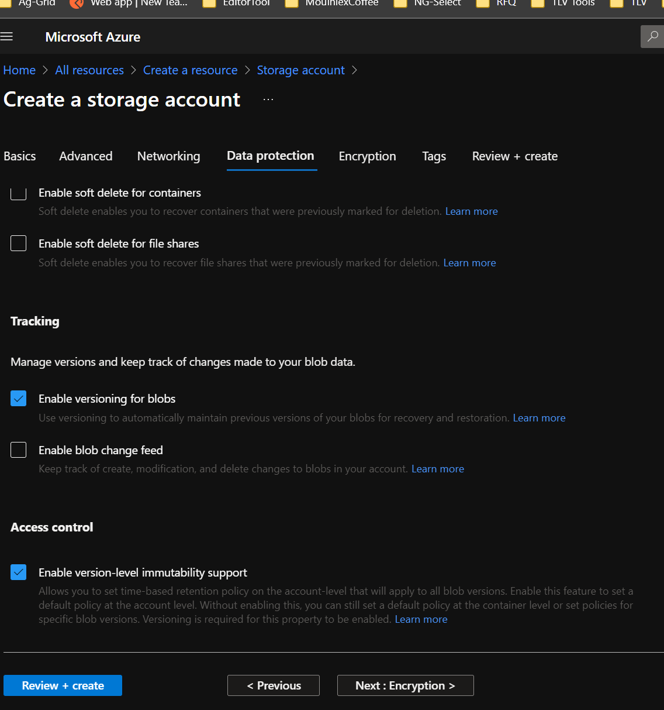

**2-on Azure storage account > Data Protection >**

**(You will see that its enable versioning for blobs && enable version level immutable)**

**3-upload text blob file on the azure storage account then click edit and make some update on text and click update you will see that it create new version**

**(Then make sure to create snapshot before apply save)**

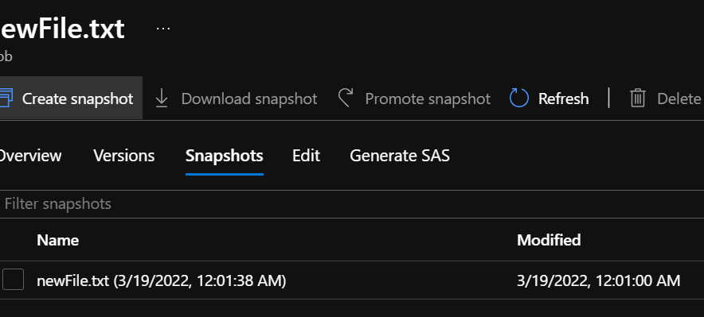

**You can restore deleted blob by check on the radio button (Show deleted blobs)**

